# **ELP-212 (Experiment 3)**

Group Members: Date of Experiment : 18 August, 2022

1. Prateek Mishra (2020EE10527)

2. Shubh Goel (2020EE10672)

3. Kanishk Goel (2020EE10503)

4. Atif Anwer (2020EE10479)

5. Manas Jain (2020EE10511)

6. Goutham Srinivas (2020EE10495)

**Objective:**

To prove the relation: $$\frac{1}{λ_{a}^{2}}-\frac{1}{λ_{g}^{2}}=\frac{1}{{\left(2a\right)}^{2}}$$

Where, 𝜆𝑔 is the wavelength in waveguide, 𝜆𝑎 is the wavelength in free space and ‘a’ is the broad dimension of the waveguide.

NOTE: we are operating in X – band region here, i.e., frequency lies between 8 GHz – 12 GHz.

**Pre-Experimental Quiz:**

**Q1.** What is the cut-off wavelength for a rectangular waveguide?

**Ans 1.** cut-off wavelength for a rectangular waveguide is:

$$λ = \frac{2}{\sqrt{\left({\left(\frac{m}{a}\right)}^{2} + {\left(\frac{m}{b}\right)}^{2}\right)}}$$

**Q2.** Rewrite the relation in question 1 so that it holds good for any mode supported by a rectangular waveguide.

**Ans:**

2 $$λ_{guide}=\frac{λ_{freespace}}{\sqrt{1-{\left(\frac{λ_{freespace}}{λ_{cutoff}}\right)}^{2}}}$$

**Theory:**

The best way to prove this relationship is to measure 𝜆𝑎 and 𝜆g and then plot the values of $\frac{1}{λ_{a}^{2}}$ against the corresponding values of $\frac{1}{λ_{g}^{2}}$. This should result in a straight-line graph which cuts the $\frac{1}{λ_{a}^{2}}$ axis at a value equal to $\frac{1}{{\left(2a\right)}^{2}}$. If this graph allows the determination of a value of width of the broad wall of the guide which agrees with the actual value as measured by

callipers then this surely is a proof of the validity of the relationship expressed in the above

equation.

To measure the waveguide wavelength, $λ_{g}$, standing waves are produced by

improperly terminating the waveguide. Secondly, the radiation is allowed to leave the

waveguide and the wavelength of the standing wave in free space $λ_{a}$ is compared with the

wavelength in the waveguide $λ_{g}$. To produce standing wave in the waveguide and in the

air, a horn is attached to the waveguide and a sheet of metal is placed a certain distance

away from the horn. The electromagnetic radiation will then leave the waveguide via the

horn into the air. It will be reflected from the sheet of metal and produce a standing wave

between the horn and the sheet with a wavelength. As the reflected wave will re-enter

the waveguide there will be a standing wave produced in the waveguide but with a

wavelength $λ_{g}$.

If the sheet is moved relative to the horn keeping its plane at right angles to

the axis of the waveguide the standing wave will move. Therefore, the signal at the

stationary probe of the standing wave detector will vary as the standing wave moves past it.

The distance moved by the sheet to repeat the output on the meter (i.e., to have the probe

at the next corresponding position on the standing wave) is half a free pace wavelength $\frac{λ_{a}}{2}$.

The voltage of the sanding wave must always be at a minimum at the sheet because it is a

good conductor. Consequently, moving the sheet moves the pattern. Therefore, when the

sheet has moved a distance $\frac{λ_{a}}{2}$, the voltage at the stationary probe of the standing wave

detector will be repeated. A measurement of the amount of movement of the sheet

determines $\frac{λ_{a}}{2}$ at the given frequency.

To determine the guide wavelength $\frac{λ_{g}}{2}$ at the same frequency all that is necessary is to

keep the sheet still and move the standing wave detector probe. The pattern will remain

stationary, and the probe will explore that pattern in the waveguide which repeats every

half guide wavelength $\frac{λ_{g}}{2}$. The distance between two adjacent minima on the scale of

standing wave detector will give $\frac{λ_{g}}{2}$.

Now knowing $\frac{λ_{g}}{2}$ and $\frac{λ_{a}}{2}$ at one frequency, these values are recorded and the whole

experiment is repeated at a new frequency. This procedure is repeated for measurement at several frequencies. The values of $\frac{1}{λ_{a}^{2}}$ and $\frac{1}{λ_{g}^{2}}$ for each frequency is plotted and

from the intersection of the graph with the $\frac{1}{λ_{a}^{2}}$ axis a value of the inside broad dimension

of the waveguide can be obtained and compared with the measured value.

**Experimental Arrangement:**

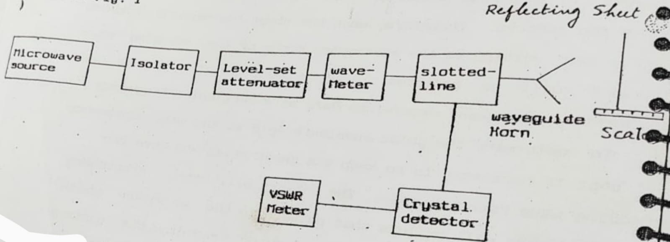

Schematic Diagram of the Experimental Setup

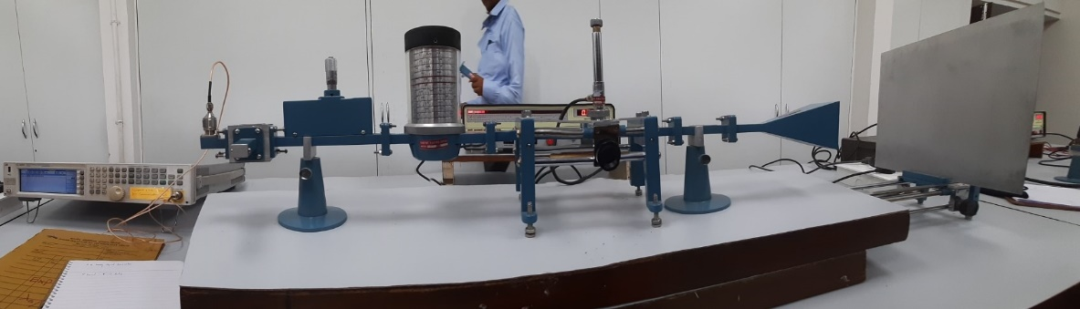

The Experimental Setup

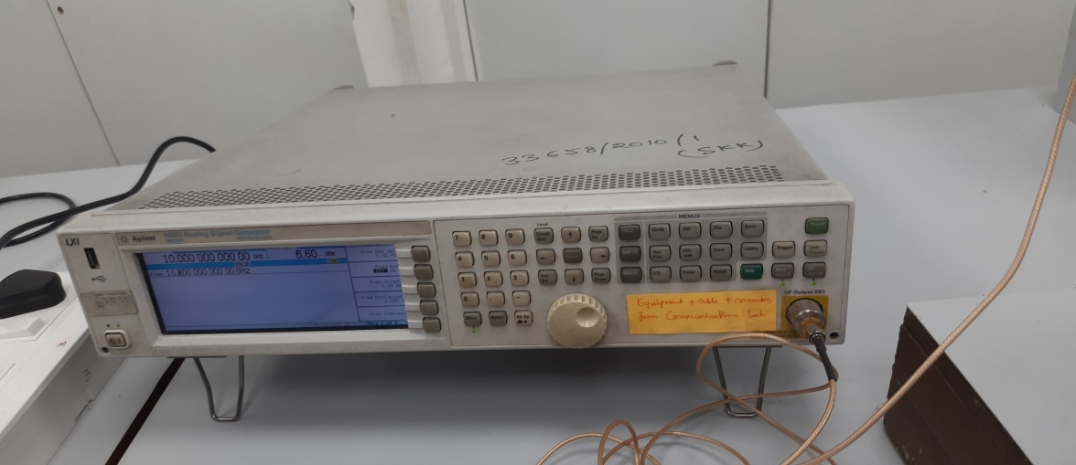

Microwave source

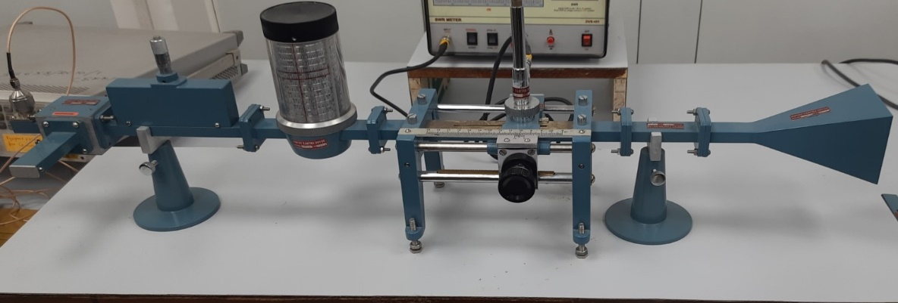

Waveguide comprising of Isolator, Attenuator, Wave Meter, Slotted Line, Horn

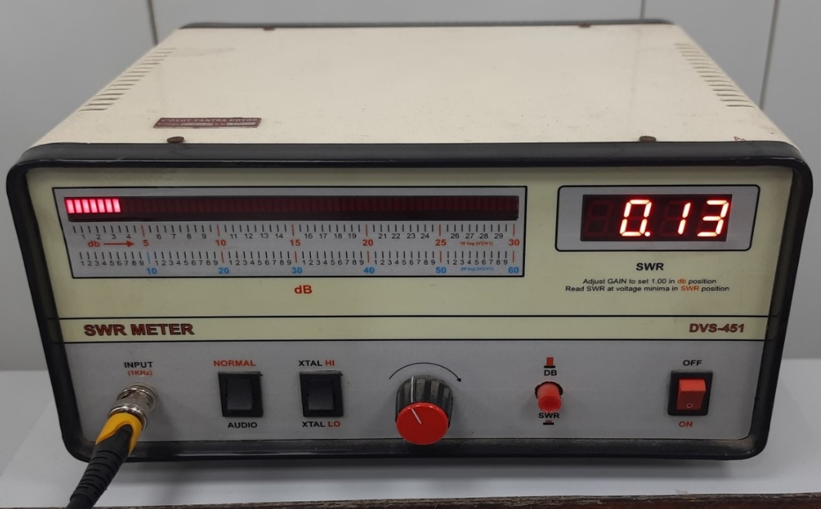

VSWR Meter

**Procedure:**

1. Microwave Signal Generator is turned on and set at, say, 9.5 GHz.
2. Now, move the metal sheet towards the waveguide horn slowly leaving the slotted-line probe fixed in one position until the probe output is maximum. Do this 4 times so that we get distances of successive maxima as x1, x2, x3. We can calculate:

𝜆𝑎  =

1. Leaving the sheet fixed in this position move the probe in the slotted-line and obtain 𝜆g / 2 in a similar fashion. Note the frequency, 𝜆𝑎 and 𝜆g in the observation table.
2. Change the frequency in steps of 1 GHz and record the observations for different frequencies at 9.5 GHz, 10.5 GHz and 11.5 GHz.

**Observations:**



From the above table, the average value of a = 2.27786 cm

Plotting the graph between ($\frac{1}{λ_{a}^{2}}$) And ($\frac{1}{λ_{g}^{2}}$):

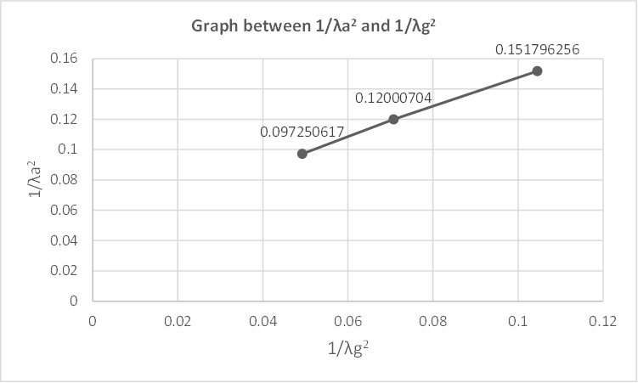

(1/(cm^2))

(1/(cm^2))

Here, we can see that the graph is almost a straight line as it follows the equation:

$$\frac{1}{λ_{a}^{2}}-\frac{1}{λ_{g}^{2}}=\frac{1}{{\left(2a\right)}^{2}}$$

The average experimentally measured value of a (2.277 cm) is also in close agreement with the actual value i.e., 2.286 cm.

**Inferences:**

During the experiment, we observed that the slotted line's final waveform depends on various factors. However, we only vary the carrier frequency, keeping all other factors constant. We observed that the wavelength of the wave in the waveguide as well in free space changes while the value of 'a' remains almost constant. The variation in these values is noticed to be in close agreement with the expression

$$\frac{1}{λ_{a}^{2}}-\frac{1}{λ_{g}^{2}}=\frac{1}{{\left(2a\right)}^{2}}$$

We also observe that plotting values of $\frac{1}{λ_{a}^{2}}$ v/s $\frac{1}{λ_{g}^{2}}$ is approximately a straight line, again agreeing with the above equation. Hence, we infer that the relation indeed holds true experimentally as well.

**Post Experiment Quiz:**

**Q1.** What care may be taken to improve the accuracy of the measurement of $λ_{a}$ and $λ_{g}$?

**Solution:**

1. Consideration of least count errors and parallax errors during measurement.
2. The resistance of the horn antenna should not be taken too close to the characteristic impedance for sufficient amplitude in signals.
3. The slider along the slotted line should be moved gradually to avoid missing a minima or maxima due to the sharpness of these points.

**Q2.** Can one utilize maxima values instead of minima values of the standing wave pattern?

**Solution:** Theoretically, it is equally valid to use maxima values. However, as maxima value is not very sharp as compared to minima value, measurement of maxima might contain significant lack of accuracy.

**Q3.** Can one use a plane dielectric in place of the metal sheet?

**Solution:** The sole purpose of using a metal sheet lies in the reflective properties and having zero electric field inside the bulk, forming a minima at the surface. Since a dielectric can have refractions of electromagnetic waves, the requirements to create a standing wave are not satisfied, and hence can’t replace the metal sheet.

**Q4.** List some sources of error which may cause a discrepancy between the estimated and measured value of $a$, the broad dimension of the waveguide.

**Solution:** Sources of error which may cause a discrepancy between the estimated and measured value of $a$, the broad dimension of the waveguide are:

1. Propagation of modes other than the dominant mode might interfere with the measurements.
2. Oblique incidence of waves on the metal sheet due to improper placement may result in imperfect standing wave patterns.
3. Incorrect impedance of the horn antenna might case immeasurable amplitudes of signals in air or the waveguide of insufficient separations between minima/maxima